* **Redux-thunk**
  + Cho phép dispatch **async action**

(Cho phép Action Creator thực hiện logic (async) trước khi trả về object action)

|  |  |  |  |  |  |
| --- | --- | --- | --- | --- | --- |
| |  |  | | --- | --- | |  |  |   *Sync action* | |  |  | | --- | --- | |  |  |   *Async action* |

* + Thunk là 1 function (currying function)
  + Thunk function có thể nhận **dispatch** và **getState** là param
    - **dispatch** (function)

function để khi có kết quả từ async action thì sẽ dispatch

* + - **getState** (function)

trả ra Global State trong Store

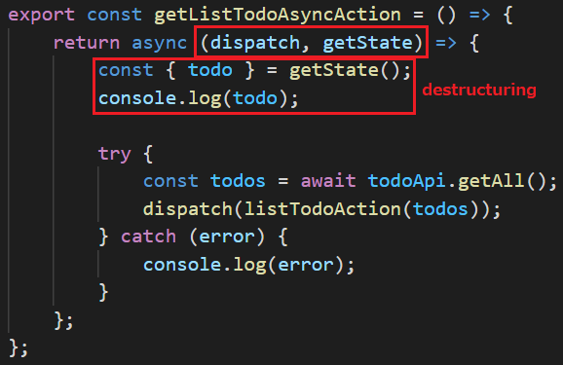

* + Flow

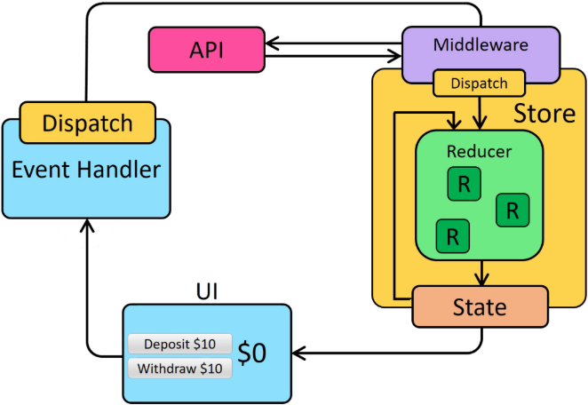

[*https://redux.js.org/assets/images/ReduxAsyncDataFlowDiagram-d97ff38a0f4da0f327163170ccc13e80.gif*](https://redux.js.org/assets/images/ReduxAsyncDataFlowDiagram-d97ff38a0f4da0f327163170ccc13e80.gif)

* VD1: logic đặt ở ngoài component

|  |  |  |
| --- | --- | --- |
|  |  |  |

*Normal*

* VD2: logic đặt vào trong Action Creator

|  |  |
| --- | --- |
|  |  |

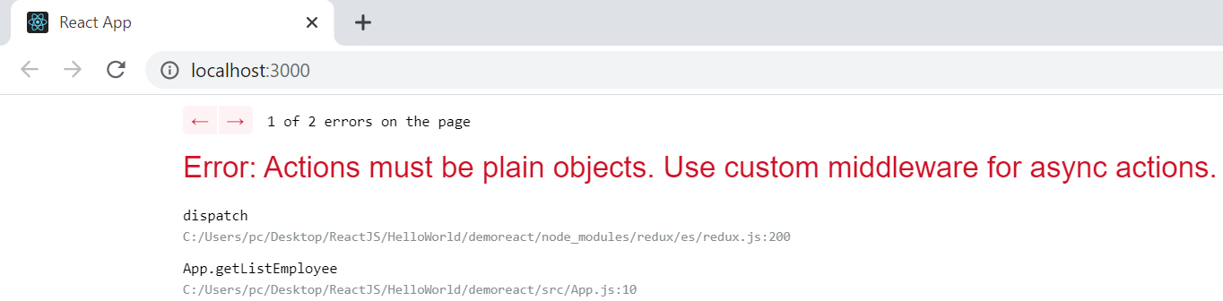

*Action chỉ có thể là function bình thường, không thể là 1 async function*

*(không thể dispatch 1 async action)*

* *Fix bằng redux-thunk*
  + **Install**

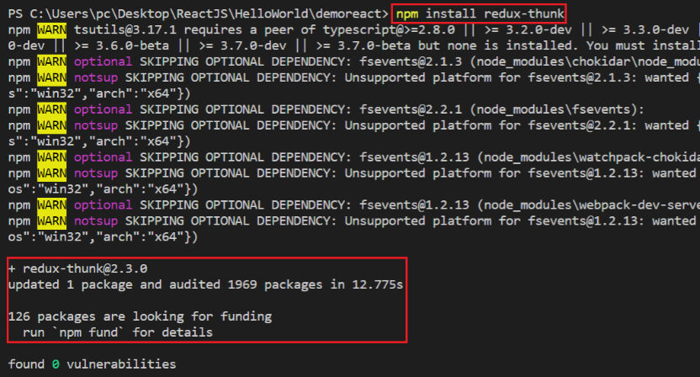

*npm install redux-thunk*

* + **Apply thunk**

|  |  |  |
| --- | --- | --- |
|  |  |  |

* VD3:

|  |  |
| --- | --- |
|  |  |

* VD4:

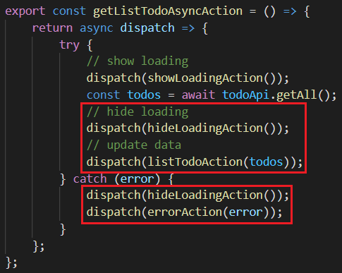

*Dispatch todo or error action*

* VD5: Show notification

<https://stackoverflow.com/questions/35411423/how-to-dispatch-a-redux-action-with-a-timeout/35415559#35415559>

* **withExtraArgument**

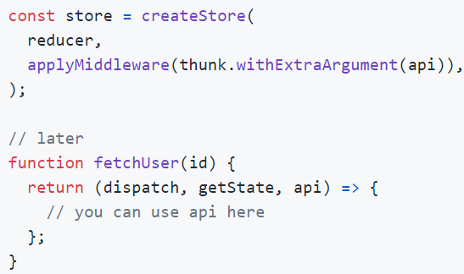

[*https://github.com/reduxjs/redux-thunk#injecting-a-custom-argument*](https://github.com/reduxjs/redux-thunk#injecting-a-custom-argument)

* **Reference**

<https://github.com/reduxjs/redux-thunk>

<https://redux.js.org/tutorials/essentials/part-5-async-logic>